Blossomflare (Floraburst Evolution)
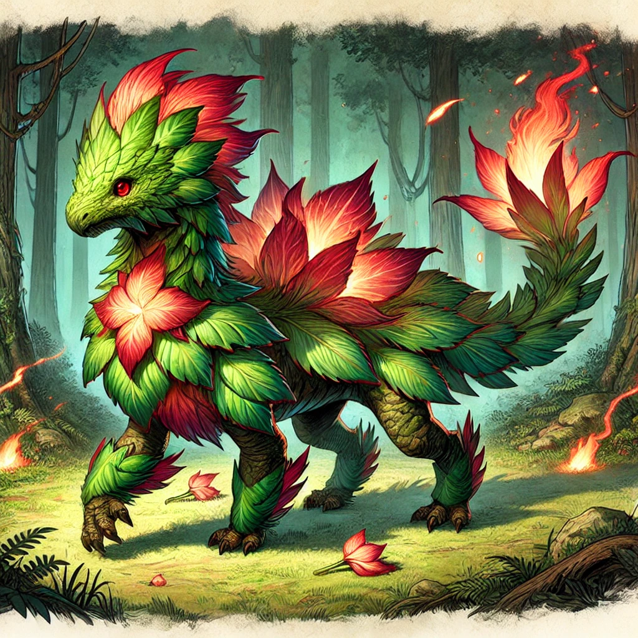
Medium Magical Beast, Neutral Good
Armor Class: 15 (Natural Armor)
Hit Points: 50 (7d8 + 14)
Speed: 25 ft.
Saving Throws: Dex +5, Wis +4
Skills: Perception +4,
Nature +4, Survival +4
Damage Resistances:
Fire 🔥, Poison 🌿
Damage Vulnerabilities: Cold ❄️
Senses: Darkvision 60 ft.,
Passive Perception 14
Languages: Understands Common
and Sylvan but cannot speak
Challenge Rating: 3 (700 XP)

STR | DEX | CON | INT | WIS | CHA
14 (+2) | 16 (+3) | 14 (+2) | 12 (+1) | 14 (+2) | 14 (+2)
Abilities
Dual Typing (Grass 🌿 / Fire 🔥):
Blossomflare’s nature embodies both grass and fire. He is resistant to Fire 🔥 and Poison 🌿 damage but vulnerable to Cold ❄️ damage.
Photosynthetic Regeneration 🌿:
If Blossomflare begins its turn in direct sunlight, it regains 3 hit points.

Actions
Multiattack:
Blossomflare makes two attacks: one with Vine Lash 🌿 and one with Flame Burst 🔥.

Vine Lash 🌿
Melee Weapon Attack: +6 to hit, reach 15 ft., one target.
Hit: 10 (2d8 + 2) bludgeoning damage. The target must succeed on a DC 13 Strength saving throw or be restrained until the end of its next turn.

Flame Burst 🔥
Ranged Spell Attack: +6 to hit, range 30 ft., one target.
Hit: 9 (2d6 + 2) fire damage. On a hit, flames erupt in a 5-foot radius around the target, dealing 2 fire damage to each creature within the area.

Floraberry 🌿 (3/Day)
As an action, Blossomflare produces 1d4 + 2 magical berries infused with energy. Each berry restores 4 hit points when eaten. A creature can use an action to eat one berry. The berries lose their potency after 24 hours.

Reactions

Flame Petals 🔥
When hit with a melee attack, Blossomflare can use its reaction to deal 1d4 fire damage to the attacker.

Friendship Bond 🌿 (2/Short Rest)
When an ally within 15 feet of Blossomflare is hit by an attack, Blossomflare can use its reaction to grant that ally temporary hit points equal to 1d6 + 3

